Report (20%, i.e. 14% of overall grade for module)

**Report (20%)**

* *Spelling, grammar & writing (5%)*
* *Analysis of similarities (7.5%)*
* *Analysis of differences (7.5%)*

*You must complete a short report, around 3-5 pages, which compares the solutions achieved using the procedural approach and the object oriented approach.*

Source: Etain’s notes - MPP - 3.2 - Practical C (Video) – 60mins

Python and C – to see similarities & differences

C is a lower level programming language than python. C is more verbose (using or expressed in more words than are needed).

Source: Etain’s notes - MPP - 3.2 - Practical C (Video) – 60mins

After exercise 3 completed in Python: Dominic mentioned we will see similar instructions in C but the user input will be slightly more difficult and we’ll have to do some things with string comparisons.

Source: Etain’s notes - MPP - 3.2 - Practical C (Video) – 60mins

Dominic comments during video MPP 3.2 while working in C that he must declare this array as having 20 characters – generally you don’t need to do this in Python as it dynamically allocates the memory (22mins);

#include <stdio.h>

int main()

{

char[20] name;

fgets(name,20,stdin);

printf("Hello, World\n");

return 0;

}

Source: Etain’s notes - MPP - 3.2 - Practical C (Video) – 60mins

Another comment made by Dominic at 25 mins;

It is more difficult in C with user input – you have to think more lower level. Example: In Python it would automatically get rid of the \n for you, whereas in C you need to remember to erase this.

\n = 2 lines appear in C;

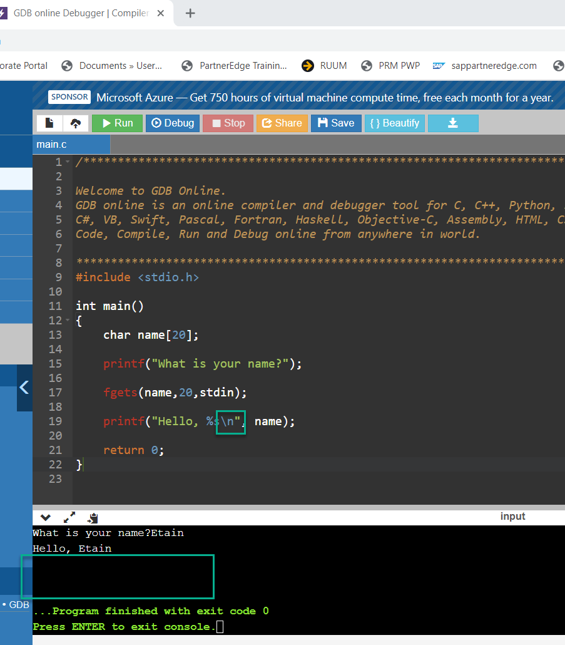

Another comment made by Dominic at 28 mins;

Error messages in C tend to be less helpful than in Python and other newer languages, although the compiler is improving all the time – the development of C is still ongoing.

Exercise 3 was more difficult in C than in Python – the cause: we allocated 20 characters for the name in C. This caused the issue. 31 mins. This is a good example of how C is a lot more low level than Python. (Review this part of video and include this in report).

Compare exercise 4 in Python and in C. There is much more to remember to do in C which Python does itself automatically. 36mins in video.

Much more low level thinking is required when writing a C program – example we needed to include an “&” symbol in C;

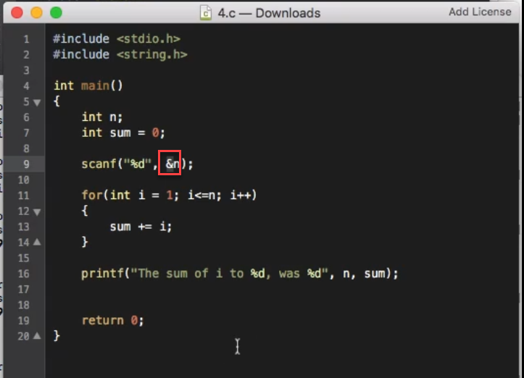

We needed to complete this in C to ensure it is treated as a reference – the “&”means it’s referring to a memory address – the memory address which has been allocated to this integer.

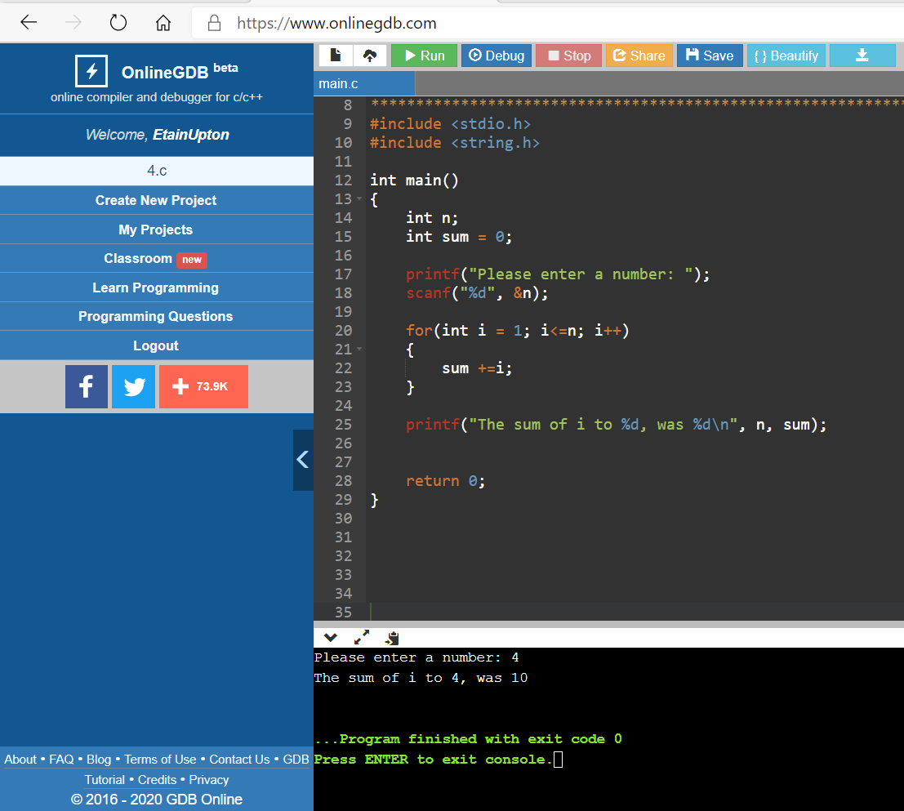

Formats of things we’re reading in

Loops are more difficult to set up in C than they are in python– we can’t just say “for i in range” for example.

The printf syntax is different to our print syntax in Python.

We use brackets instead of indentation.

Dominic mentions that in C everytime we open a brace { we should indent. This keeps things structured. However, C doesn’t care about indentation – it will run regardless.

I personally find Python less complicated to use – it is more straightforward and user friendly.

For exercise 5 We can use the modulous operator so it will be similar to how it appears in Python.